PROJECT PROPOSAL
Empowering Mothers and Youth through Sustainable Microenterprise and Livelihood Development
Northwestern Ethiopia
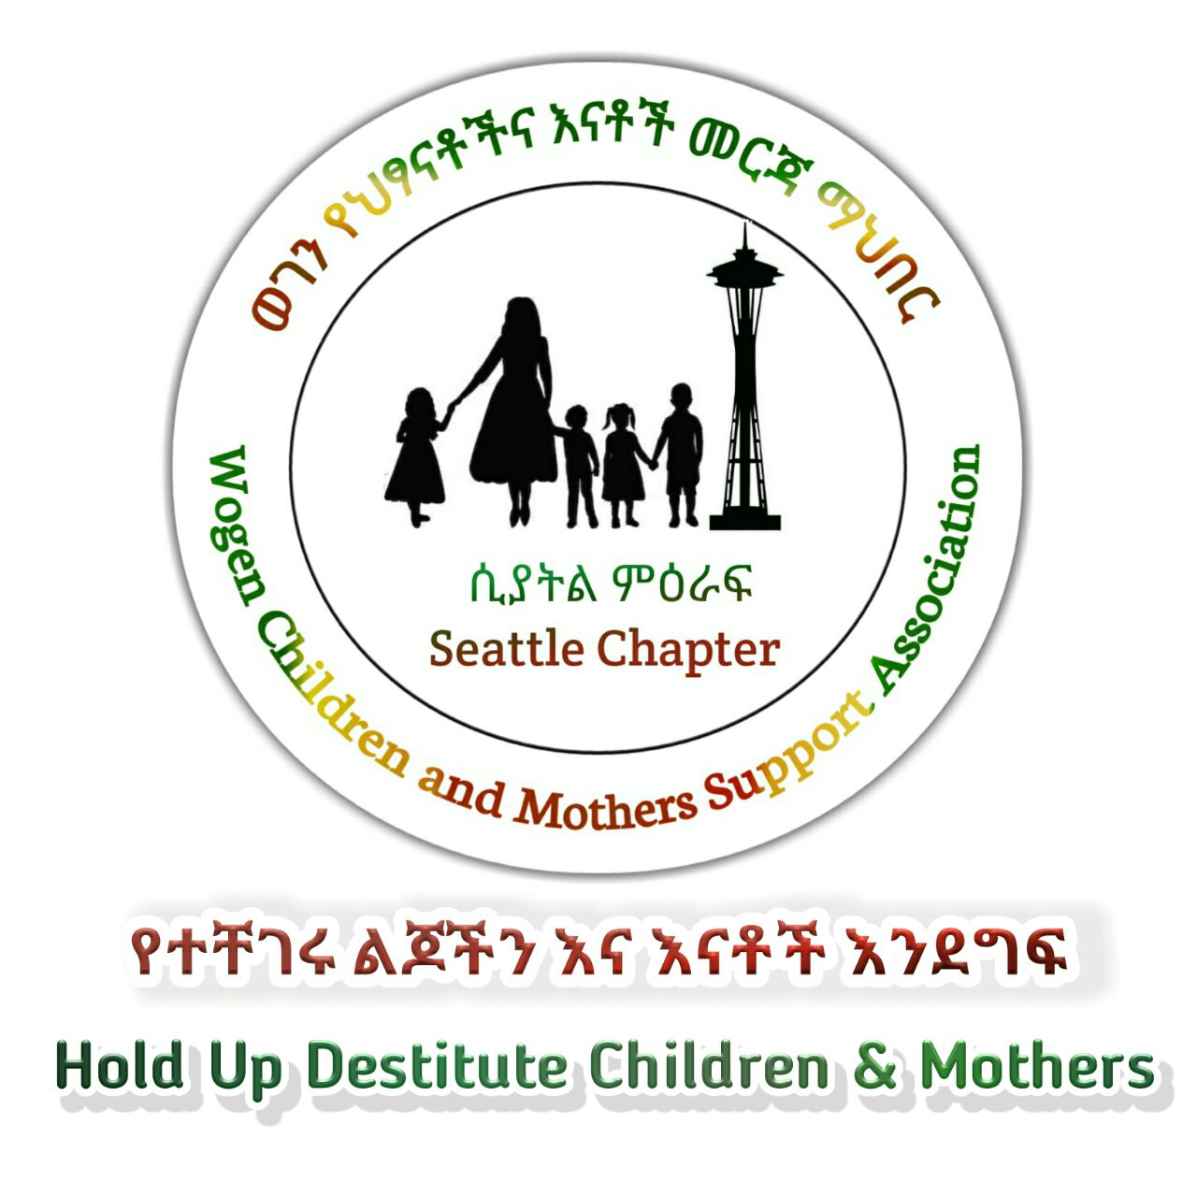
Proposed by
Wogen Children and Mothers Support Association -Seattle Chapter (WCMSASC)
Implementation period: October 2026 -December 2027
Geographic coverage: Five districts and seven towns
Direct beneficiaries: 49 (35 mothers and 14 youth)
Revolving enterprise capital: ETB 1,820,000.00
September 2026

Contents
1. Executive Summary 1
2. Project at a Glance 2
3. Background and Rationale 2
4. Problem Statement 3
5. Goal, Objectives and Specific Results 3
6. Target Beneficiaries and Selection 4
7. Enterprise and Livelihood Model 4
8. Revolving Fund Design and Financial Management 5
9. Implementation Strategy 6
10. Government and Stakeholder Collaboration 7
11. Monitoring, Evaluation, Accountability and Learning 7
12. Risk Analysis and Mitigation 8
13. Sustainability and Exit Strategy 9
14. Gender, Youth and Social Inclusion 9
15. Project Value and Replicability 9
16. Implementation Timeline 10
17. Budget Framework 10
Proposed co-financing / in-kind contribution 11
18. Accountability, Reporting and Governance 11
19. Key Success Criteria for Continuation 11

1. Executive Summary

Wogen Children and Mothers Support Association - Seattle Chapter (WCMSASC) proposes a practical livelihood and microenterprise initiative for economically disadvantaged mothers and youth in five districts of northwestern Ethiopia. The project builds on approximately three years of experience supporting mothers and needy youth to plan and establish small income-generating activities. During 2023-2024, WCMSASC provided non-repayable seed capital in selected towns; from 2025, the organization shifted to an interest-free revolving-fund model. The existing experience is reported by WCMSASC to have achieved a success rate of more than 80%.
The proposed project will extend and strengthen this model in seven towns: Koladiba, Maksegnit, Amba Giorgis, Aykel, Seraba, Tikildingay and Erobit, covering Lay Armachiho, Chilga, East Dembia, Gondar Zuria and Wogera districts. Forty-nine participants will be selected-five mothers and two youth in each town. Participants will receive practical business preparation, financial literacy, behavioral/life-skills support, mentoring and access to interest-free revolving enterprise capital. Each mother will receive up to ETB 40,000 and each youth up to ETB 30,000, for a total revolving capital fund of ETB 1,820,000.
The project is designed around a simple sustainability mechanism. Beneficiaries will be organized into seven-member mutual-support cohorts. A seven-month grace period will allow businesses to stabilize before repayment begins. Each participant will then repay the interest-free capital over 17 months, after which recovered funds will be redeployed to new beneficiaries. This converts a one-time donation into a continuing community livelihood fund.
The project will be implemented in partnership with relevant district and town administration offices, particularly offices responsible for women, children and youth affairs, labour and skills offices. Government partners will support project participants identification, training, business linkage, social support, monitoring and local coordination, while WCMSASC will provide financing, technical oversight, mentoring, accountability and learning.
The project seeks not simply to distribute money, but to establish a repeatable pathway from vulnerability to productive self-employment: selection → skills and behavioral preparation → business planning → capital → mentoring → savings and repayment → reinvestment. The immediate result will be 49 supported entrepreneurs; the longer-term objective is a locally anchored revolving mechanism capable of reaching additional mothers and youth after the initial cycle.

2. Project at a Glance
Item | Proposed design
Project title | Empowering Mothers and Youth through Sustainable Microenterprise and Livelihood Development
Lead organization | Wogen Children and Mothers Support Association - Seattle Chapter (WCMSASC)
Implementation period | October 2026 - December 2027
Geographic coverage | Five districts; seven towns
Towns | Koladiba, Maksegnit, Amba Giorgis, Aykel, Seraba, Tikildingay and Erobit
Districts | Lay Armachiho, Chilga, East Dembia, Gondar Zuria and Wogera
Direct beneficiaries | 49: 35 mothers and 14 youth
Business capital | ETB 1,820,000
Capital allocation | 35 mothers × ETB 40,000; 14 youth × ETB 30,000
Financing model | Interest-free revolving enterprise fund
Grace period | 7 months
Repayment period | 17 months after grace period
Primary approach | Skills + business planning + finance + mentoring + market linkage
Sustainability mechanism | Repaid capital is redeployed to subsequent participants

3. Background and Rationale

Mothers and young people experiencing socioeconomic disadvantage often face a combination of limited productive assets, inadequate employment opportunities, low access to finance and weak connections to markets and support services. For individuals who are able and willing to work, the absence of modest start-up capital can prevent them from turning practical skills or small business ideas into functioning livelihoods.
WCMSASC's previous support provides the foundation for the proposed intervention. In 2023 and 2024, the organization supported mothers and needy youth with non-returnable seed money in Aykel, Seraba, Tikildingay and Erobit. Beginning in 2025, WCMSASC introduced an interest-free revolving-fund approach and expanded coverage to Koladiba, Aykel, Seraba, Tikildingay and Erobit. The organization reports a success rate of more than 80% and reports that participants have been able to save, strengthen household self-reliance and improve their ability to meet basic needs.
The proposed project retains the strongest feature of this experience-the combination of small-scale capital with practical support-but introduces a clearer project cycle, transparent beneficiary criteria, business planning, cohort accountability, repayment tracking, monitoring indicators and learning. Two towns, Maksegnit and Amba Giorgis, are new locations under the proposed expansion, while the other five towns have prior experience with the initiative.
The intervention is, therefore, justified as a scale-and-strengthen phase rather than a completely new experiment. Its comparative advantage is its relatively small financing package, local institutional relationships and revolving-fund design, which can enable the same pool of capital to support successive cohorts.

4. Problem Statement
The project addresses four interconnected constraints:
- Limited access to start-up capital for economically disadvantaged mothers and youth who have viable small-business ideas but insufficient resources to initiate or expand them.
- Skills and business-management gaps, including financial management, costing, pricing, savings, customer relations and basic record keeping.
- Weak transition from training to actual income generation when practical mentoring, market linkage and follow-up are absent.
- Dependence on one-off assistance when grant capital is not designed as a mechanism for recovery, reinvestment and expansion.
The proposed response is intentionally modest in scale. Rather than attempting to solve unemployment or poverty at a population-wide level, the project will demonstrate and strengthen a practical microenterprise pathway for a defined group of 49 participants, while creating a revolving mechanism for subsequent beneficiaries.

5. Goal, Objectives and Specific Results
Overall goal: To improve the economic self-reliance and livelihood security of disadvantaged mothers and youth through practical skills development supported self-employment and an interest-free revolving enterprise fund.
Specific objectives
- Provide 49 selected mothers and youth with practical business, financial literacy, work-ethics and life-skills support.
- Enable 49 participants to establish or strengthen small-scale income-generating activities based on realistic individual business plans and local market opportunities.
- Provide ETB 1,820,000 in interest-free revolving enterprise capital and establish a transparent repayment and reinvestment system.
- Strengthen participants' capacity to save, manage cash flow, keep basic records and operate their enterprises responsibly.
- Create a structured mentoring, monitoring and local referral mechanism linking beneficiaries with relevant government offices, markets and service providers.
- Generate evidence and lessons for replication in additional towns and districts.

6. Target Beneficiaries and Selection
The project will directly support 49 people: 35 mothers and 14 youth. Each of the seven participating towns will form one cohort of seven participants—five mothers and two youth.
Location | Mothers | Youth | Total
Each town | 5 | 2 | 7
Seven towns | 35 | 14 | 49

Project participants selection should prioritize people who are economically disadvantaged but have the capacity, motivation and practical opportunity to engage in productive work. Final selection will be conducted transparently with relevant local government partners and community structures.
Recommended selection criteria
- Demonstrated economic vulnerability and limited access to productive capital.
- Willingness and ability to engage actively in an income-generating activity.
- A realistic business idea or an existing microenterprise with potential for improvement.
- Availability of sufficient time and commitment to manage the proposed activity.
- Willingness to participate in training, mentoring, cohort meetings, savings activities and repayment.
- Preference for applicants whose proposed businesses respond to identifiable local demand.
- Priority to women/mothers and youth who are not already benefiting from comparable livelihood-financing programs.
The project should avoid selecting participants solely because of personal relationships or ability to provide a guarantor. Any security or guarantee arrangement should be proportionate to the size of the financing and should not exclude the poorest intended beneficiaries.

7. Enterprise and Livelihood Model
The project will not prescribe a single business type. Participants will identify enterprises appropriate to their skills, resources, location and market demand. Examples may include small trading activities, food processing, services, petty commerce, tailoring, repair and other locally viable activities, subject to local regulations and market assessment.
Before capital is released, each participant should complete a simple business plan covering: product/service, customers, start-up requirements, expected sales, operating costs, estimated profit, risks and repayment capacity. WCMSASC and local partners will review plans before disbursement.

Enterprise support sequence
- Identify participant and enterprise opportunity.
- Provide practical and behavioral preparation.
- Develop a simple business plan and budget.
- Verify market feasibility and avoid excessive concentration in the same activity.
- Approve and release capital against an agreed enterprise plan.
- Provide mentoring and troubleshooting during the first months.
- Track sales, savings, business performance and repayment.
- Recover capital and redeploy it to subsequent beneficiaries.

8. Revolving Fund Design and Financial Management
The proposed ETB 1,820,000 will be treated as an interest-free revolving enterprise fund. Mothers will receive ETB 40,000 each and youth ETB 30,000 each. The funds are intended for approved productive activities rather than general household consumption.
Beneficiary group | Number | Allocation per person | Total
Mothers | 35 | ETB 40,000 | ETB 1,400,000
Youth | 14 | ETB 30,000 | ETB 420,000
Total | 49 | — | ETB 1,820,000

A seven-month grace period is proposed so participants can establish their businesses before repayment starts. Following the grace period, each participant will repay the principal over 17 months without interest. Recovered funds will be deposited into the revolving fund and allocated to new participants in subsequent cycles.
Financial controls
- Maintain a separate project/revolving-fund ledger.
- Use documented beneficiary agreements showing amount, grace period, repayment schedule and permitted use.
- Release funds only after business-plan approval and completion of required training.
- Record every disbursement and repayment against an individual beneficiary code.
- Conduct quarterly reconciliation of the revolving fund.
- Report repayment rate, outstanding balance, arrears and funds redeployed.
- Maintain documentation sufficient for donor financial review.

9. Implementation Strategy
Phase 1: Mobilization and selection - October 2026
- Confirm participating towns and local government focal persons.
- Conduct community information and beneficiary mobilization.
- Screen and select 49 participants.
- Establish seven town-based cohorts.
Phase 2: Capacity building - November 2026
- Practical business skills and work ethics.
- Financial literacy, savings, budgeting and record keeping.
- Basic entrepreneurship and customer management.
- Business planning and enterprise risk management.
- Behavioral/life-skills support and problem-solving.
Phase 3: Business planning and capital release - December 2026 to January 2027
- Finalize individual business plans.
- Review local market feasibility.
- Approve enterprise budgets.
- Complete beneficiary agreements.
- Release capital in a controlled and documented manner.
Phase 4: Mentoring and enterprise strengthening - February to June 2027
- Regular enterprise visits and mentoring.
- Troubleshoot business and cash-flow problems.
- Support savings and basic record keeping.
- Link participants with relevant local market and government services.
Phase 5: Monitoring, repayment preparation and learning -March to December 2027
- Quarterly performance monitoring.
- Prepare participants for repayment.
- Track business survival and income changes.
- Document lessons and case studies.
- Review the revolving-fund cycle and identify improvements for the next cohort.

10. Government and Stakeholder Collaboration
Stakeholder | Proposed role
Women, Children and Youth Affairs offices | Support identification of vulnerable mothers/youth, social inclusion, referrals and coordination.
Employment/workforce development offices | Support vocational and employment-related training, enterprise linkage and relevant local services.
Town/municipality offices | Facilitate appropriate market spaces, local registration/referral and business operating information where applicable.
Social/community service offices | Support vulnerable participants, referrals and social integration.
Local business/community actors | Provide market information, mentorship, supply/customer linkages and practical advice where feasible.
WCMSASC in-country representatives | Coordinate implementation, financial documentation, mentoring, monitoring, stakeholder coordination and reporting.
WCMSASC Seattle Chapter | Provide financing, strategic oversight, governance, accountability and technical guidance.

11. Monitoring, Evaluation, Accountability and Learning
Monitoring will focus on whether participants establish viable businesses, use funds for intended purposes, improve financial-management practices, generate income, save and repay. The project will distinguish between outputs (what the project delivers) and outcomes (what changes for participants).
Indicator | Baseline | Target | Means of verification | Frequency
Participants selected and trained | 0 | 49 | Attendance and training records | Monthly during start-up
Women/mothers supported | 0 | 35 | Beneficiary register | Once at selection
Youth supported | 0 | 14 | Beneficiary register | Once at selection
Enterprise capital disbursed | 0 | ETB 1,820,000 | Financial records | Per disbursement
Business plans approved | 0 | 49 | Signed business plans | Before disbursement
Participants operating an enterprise after start-up | To be established | At least 80% | Enterprise monitoring visits | Quarterly
Participants maintaining basic business records | To be established | At least 80% | Record review/mentor checklist | Quarterly
Repayment compliance | 0 | At least 80% of scheduled amounts by project close | Repayment ledger | Monthly/quarterly
Participants receiving mentoring | 0 | 100% | Mentoring records | Quarterly
Participants reporting improved household economic security | To be established | At least 70% | Endline survey/interviews | Endline
Funds recovered and available for next cycle | 0 | Documented and reconciled | Revolving-fund ledger | Quarterly

The 80% enterprise-success target is proposed as a realistic project benchmark because WCMSASC reports more than 80% success in its previous experience. At project inception, the team should define 'enterprise success' precisely-for example, an enterprise operating after a specified period and meeting agreed minimum performance criteria-rather than using the term as a subjective assessment.

12. Risk Analysis and Mitigation
Risk | Potential effect | Mitigation
Business failure or weak market demand | Loss of income and repayment difficulty | Market screening, business-plan review, diversification and close mentoring.
Misuse of capital | Reduced enterprise performance | Documented business plans, staged verification and follow-up visits.
Repayment default | Reduced revolving-fund sustainability | Clear agreements, cohort accountability, early arrears follow-up and tailored support.
Over-concentration in similar businesses | Local market saturation | Review business plans collectively and encourage market diversification.
Exclusion of poorest participants by guarantee requirements | Reduced equity and reach | Use proportionate, inclusive security arrangements and cohort mechanisms.
Inflation/input-price changes | Reduced purchasing power of start-up capital | Use realistic costing and encourage low-fixed-cost enterprises.
Weak coordination among institutions | Delays and fragmented support | Designate focal persons and hold periodic coordination reviews.
New locations have limited experience | Implementation quality may vary | Use experienced towns as learning sites and provide additional start-up mentoring in new towns.

13. Sustainability and Exit Strategy
Sustainability is built into the financing mechanism rather than depending solely on continued donor grants. The principal sustainability mechanism is repayment of interest-free capital and its redeployment to new participants. The project will also strengthen participants' own savings, business-management skills and local support networks.
Exit pathway
- WCMSASC provides initial capital, systems, training and intensive mentoring.
- Local cohorts gradually take greater responsibility for savings, peer accountability and repayment tracking.
- Government partners continue referrals, training opportunities and local service linkage.
- After the initial project period, recovered capital remains available for the next cycle, subject to WCMSASC governance and agreed procedures.
- WCMSASC reduces direct operational involvement as businesses stabilize, while retaining periodic oversight of the revolving fund and reporting.
The project should therefore be presented to donors as a catalytic investment: donor resources finance the first capital cycle and the project builds a mechanism that can continue supporting additional beneficiaries from recovered principal.

14. Gender, Youth and Social Inclusion
Women/mothers are the majority of direct beneficiaries (35 of 49), while youth constitute 14 participants. The design recognizes that women and youth may face different barriers and therefore combines common business support with participant-specific mentoring. Selection and monitoring should pay attention to whether women and youth can actually control and use the capital for the approved enterprise.
- Maintain sex- and age-disaggregated beneficiary and outcome data.
- Ensure training schedules and locations are reasonably accessible to women and youth.
- Monitor control and use of enterprise capital, not merely receipt of funds.
- Provide referral pathways for participants requiring social or protection-related support.
- Use participant feedback to adjust mentoring and enterprise support.

15. Project Value and Replicability
The project offers donors a relatively low-cost, testable and potentially repeatable livelihood model. The initial investment directly reaches 49 entrepreneurs, while the revolving mechanism is intended to extend the value of the original capital beyond the first cohort. The model can also generate practical evidence on which business types, support packages and repayment arrangements work best in different towns.
Replication should be evidence-led. WCMSASC should document enterprise survival, repayment performance, participant income and savings changes, business-sector performance and implementation costs. Expansion should then prioritize towns where local government collaboration, market opportunities and participant demand are sufficiently strong.

16. Implementation Timeline
Activity | Oct 2026 | Nov 2026 | Dec 2026 | Jan 2027 | Feb-Jun 2027 | Jul-Dec 2027
Mobilization and stakeholder coordination | ✓
Beneficiary selection and cohort formation | ✓ | ✓
Training and business planning |  | ✓ | ✓
Business-plan review and capital release |  |  | ✓ | ✓
Mentoring and enterprise support |  |  |  | ✓ | ✓ | ✓
Quarterly monitoring |  |  |  | ✓ | ✓ | ✓
Repayment preparation/repayment tracking |  |  |  |  |  | ✓
Learning, documentation and review |  |  |  |  |  | ✓
End-of-cycle review and next-cycle planning |  |  |  |  |  | ✓

17. Budget Framework
The source concept note identifies ETB 1,820,000 as the total project budget and allocates the full amount to revolving enterprise capital. The detailed implementation budget below preserves that figure. Training, monitoring, coordination and oversight are expected to be provided through WCMSASC and government/in-country partner contributions unless a separate operational budget is secured.
Budget item | Unit | Quantity | Unit cost (ETB) | Total (ETB)
Enterprise capital – mothers | Beneficiary | 35 | 40,000 | 1,400,000
Enterprise capital – youth | Beneficiary | 14 | 30,000 | 420,000
Total revolving enterprise fund |  |  |  | 1,820,000

Proposed co-financing / in-kind contribution
- WCMSASC: project management, strategic oversight, reporting and implementation support.
- Government partners: beneficiary mobilization, training/referral support, coordination and monitoring collaboration.
- Participants: time, labor, enterprise management, savings and repayment of principal.
For a donor submission, the final budget should be accompanied by a one-page budget narrative specifying what the requested donor funds cover and what WCMSASC/government partners will contribute in cash or in kind. If the donor requires project-management and monitoring costs to be included in the grant, the budget should be revised before submission rather than leaving these costs implicit.

18. Accountability, Reporting and Governance
- WCMSASC will maintain responsibility for overall financial stewardship and project oversight.
- In-country representatives will coordinate day-to-day implementation and maintain beneficiary, enterprise and financial records.
- Local government focal persons will participate in agreed coordination and monitoring activities.
- Progress reports will be prepared at least semi-annually for the WCMSASC Board and donor, with quarterly internal monitoring.
- Financial records will reconcile disbursement, repayment, outstanding balances and funds available for the next cycle.
- Participant feedback will be collected periodically and incorporated into implementation adjustments.

19. Key Success Criteria for Continuation
Continuation or expansion should be based on evidence rather than only on the number of participants reached. Suggested criteria include:
- At least 80% of participants operating enterprises at the agreed assessment point.
- At least 80% compliance with scheduled repayment by project close, recognizing that the full 17-month repayment period extends beyond the initial implementation period.
- Clear evidence that recovered funds are protected and available for a subsequent cycle.
- Improvement in business-management practices and savings behavior.
- Positive participant and stakeholder feedback.
- Evidence that the model can be managed at reasonable cost and adapted to new locations.

